SN-75532572 (Out Of Range Recovery Procedure)

By [Motion Systems](https://motionsystems.eu/author/admin/)2018-11-20

# Symptoms

* yellow SAFETY light is on
* at least one arm is in the bottom lowest position (or at the top highest position)
* the motion platform does not perform start-up calibration

# Causes

1. All devices: overloading ended up in out of range situation.
2. PS-2RM-150/PS-6TM-150: Mixed cables connection, e.g. BUS 1 cable is connected to BUS 2 cable.
3. PS-2RM-150/PS-6TM-150: These motion platforms are not equipped with electro-mechanical brakes.
   1. This may cause that arms move down while the motion platform is being shipped, especially when a payload is attached to the top frame.
   2. This may cause out of range situation when the arms are rotating at full speed and safety switch is triggered when arms are close to operation range bound (the arms do not stop immediately without electro-mechanical brakes).

# Applies to following motion platforms

* PS-2RM-150
* PS-6TM-150
* PS-3TM-LP550
* PS-6TM-1500
* PS-6TM-2500

# 

# Recovery procedure (online button)

This method might not work when your motion platform has older revision of PS-SB230FI power cabinet. **Before you begin, double check all cables connections**.

1. Press and hold **Online** button (front panel of the bottom PS-SB230FI)
2. The yellow light should be off now
3. Press **Start** button – the motion platform should recalibrate.
4. Once it is done, release **Online** button
5. Go to **Platform Diagnostic** and move top frame up

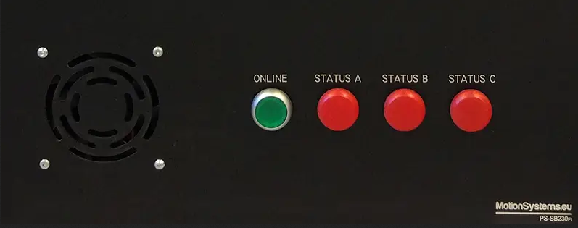

# Recovery procedure (quick code)

This method might not work if your motion platform has older firmware. **Before you begin, double check all cables connections**.

1. Open platform maanger
2. Go to **Tool & Diagnostic**
3. Click **Devices**
4. Click **Quick Codes**
5. Enter following quick code:

83634e3f

1. The yellow light should be off now
2. Press **Start** button – the motion platform should recalibrate.
3. Once it is done, go to **Platform Diagnostic** and move top frame up
4. Turn off the main power switch (it will disable the temporary bypass)

# Recovery procedure (command line tool)

This method might not work if your motion platform has older firmware. **Before you begin, double check all cables connections**.

1. Download command line tool: [mosyct.exe](https://motionsystems.eu/files/3757230870e17ac7/mosyct.zip)
2. Make sure that all safety switches are released
3. Start command prompt and enter following command:

mosyct.exe usb bypass-motion-base-emcy

1. The yellow light should be off now
2. Press **Start** button – the motion platform should recalibrate.
3. Once it is done, go to **Platform Diagnostic** and move top frame up
4. Turn off the main power switch (it will disable the temporary bypass)

# Recovery procedure (jumper)

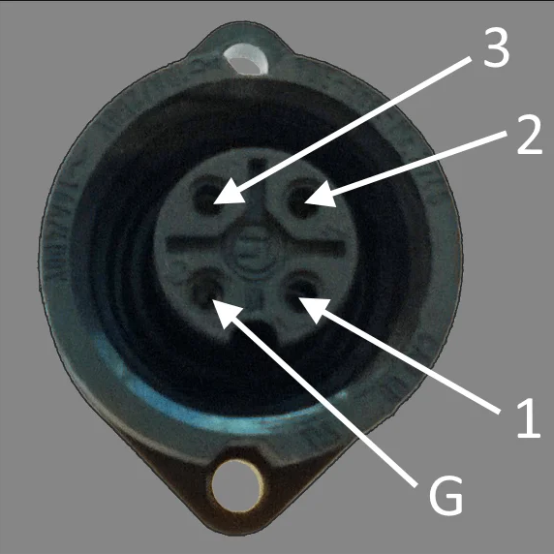Turn off the platform.

1. Disconnect the SAFETY plug
2. Prepare a short cable that can be used as a jumper between PIN 1 and 2 on SAFETY socket on the power cabinet  
   (to make a “bridge” with some wire). Pay close attention to the labels on the socket.
3. Turn on the platform with POWER SWITCH, then with the POWER LOCK (key).
4. Check the SAFETY INDICATOR light – it should be on.
5. Insert a bridge cable between PIN 1 and 2 and check if SAFETY INDICATOR light is off.
6. **If the SAFETY INDICATOR light is still ON, then please abort and contact technical support.**
7. Next keeping hand on SAFETY BUTTON just in case, press START and monitor what is going on.
8. The device should start calibration process – all arms should move back to the operating range. When the process is done, press the SAFETY BUTTON.
9. Turn the motion platform off.
10. Remove bridge and connect regular SAFETY plug.
11. Perform normal start routine to verify if the motion platforms works correctly.

# Additional recovery procedure

# (blind spot in arm)

Normally when the arm triggers the sensor, the system treats it as base position. However if the arm is already triggering the sensor when the system is turned on, then the first step is to move away of the sensor (reversed rotation) and then move back. In rare cases arm might have passed the sensor and it is in blind spot. The system is not aware that the rotation direction should be reversed and it keeps hitting the out-of-range switch or bracket. For these type of cases, below procedure can be used to bring the arm back to operation range.

**NOTE:** It has to be combined with one of the EMCY by-pass procedures.

1. Turn on the system, but do **NOT** press Start button
2. Go to **Platform Manager**, **Platform Diagnostic**, **Motor Position Control**
3. Move all M1 to M6 sliders to 0 (zero)
4. Keep **Platform Diagnostic window** open
5. Go to **Platform Manager**, **Devices,** **Quick Code**
6. Enter following code to disable reference run: **40d61d7c**
7. Enter following code to bypass EMCY: **83634e3f**
8. Press **Start** button. The top frame/arms will not move because reference run is disabled.
9. Switch to **Platform Diagnostic** window and use M1 to M6 sliders to move all arms into operation range. Please be aware that reference position might be different for each arm, so use small steps and only perform necessary movements.
10. Once all arms are back in operation range, turn the power off
11. Turn the power on and press **Start** button. Everything should work normally.